YSGOL Y Graig Primary School
PROSPECTUS-HANDBOOK
2019-2020

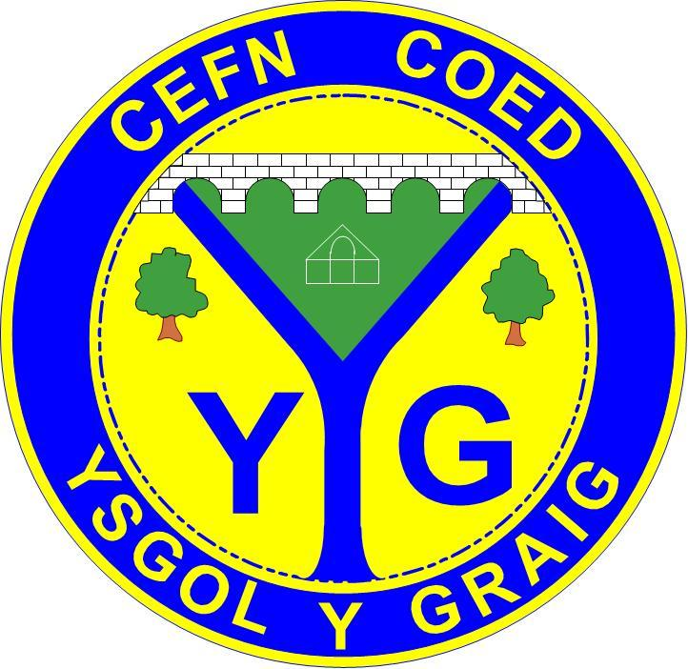
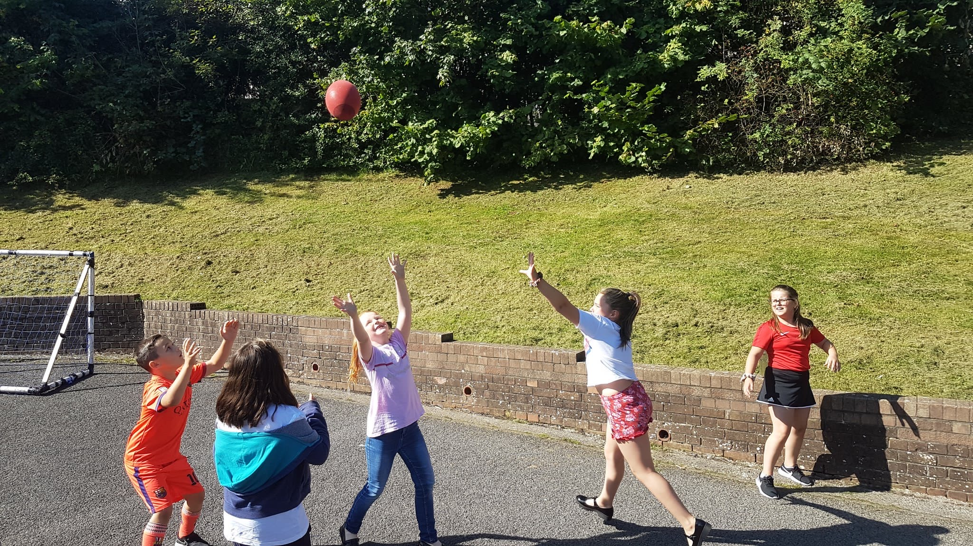
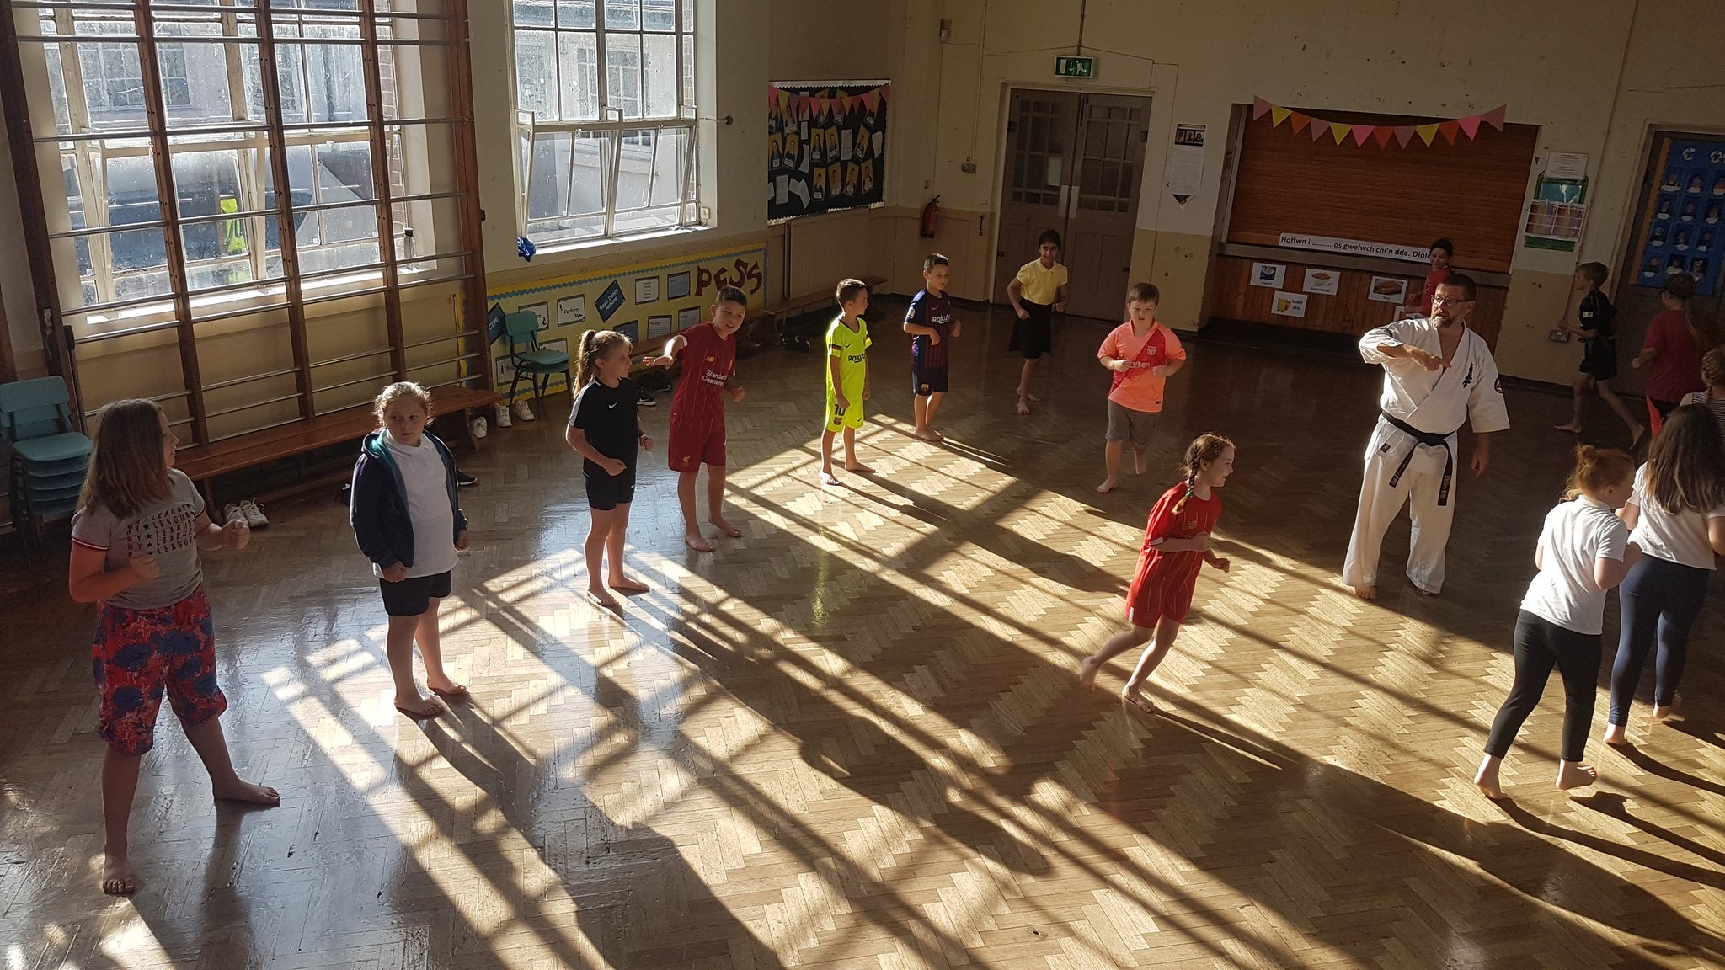

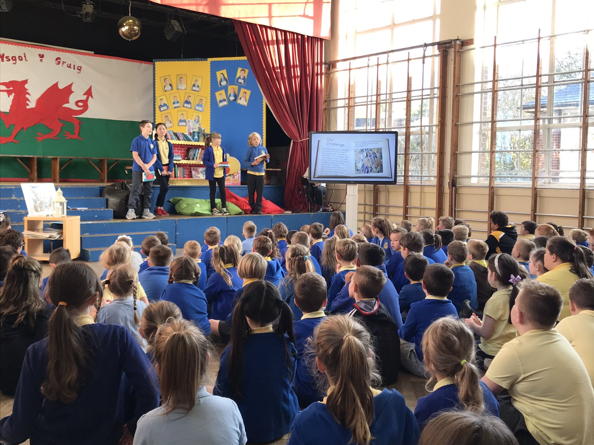

‘Opening eyes, developing minds, changing lives’

Contents Page

- Welcome to Ysgol Y Graig Primary School & Headteacher’s Message
- Contact Information
- Our Vision
- Key Information
- Our Staff
- Governing Body
- Safeguarding
- The School and the Curriculum
- Pupil Voice
- Home-school Links
- Class Themes of Study
- Termly Dates
- Pupil Attainment
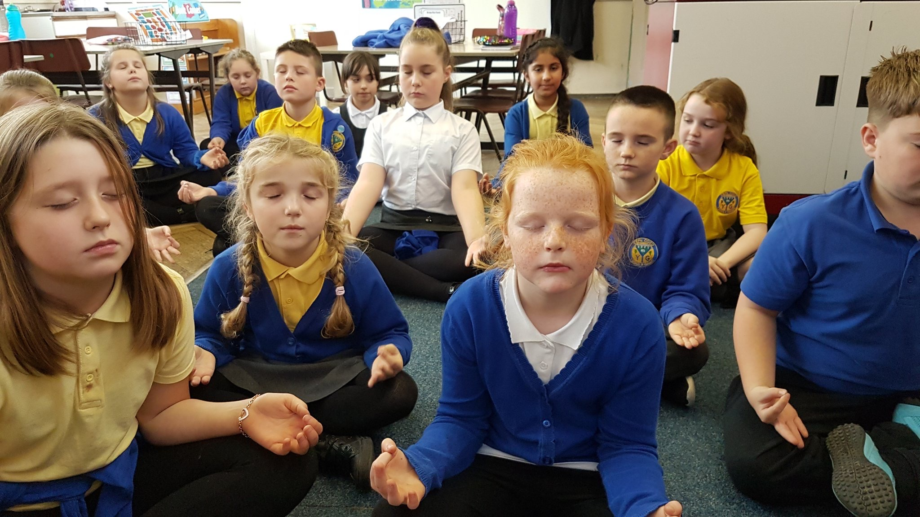

Welcome to Ysgol Y Graig
Ysgol Y Graig Primary School serves the community of Cefn Coed Y Cymmer and was established in 1932. The school typically educates 200 pupils aged between three and eleven. The school has over 20 staff. In addition to Nursery through to Year Six provision, the school also provides a base for a pilot Nurture setting. The current site is scheduled for decommission in 2020 as Ysgol Y Graig moves to our new 21st Century School. In advance of this, the Nursery facility moved from the Trefechan site to the main campus in September 2019. Pupils are now taught in single form entry classes.

A message from the headteacher
Dear Parent,
I would like to take this opportunity to welcome you to our school, to the activities and experiences that will be offered to your child whilst here at Ysgol Y Graig.
Some children will be eager to begin this new adventure and yet some will be nervous and apprehensive. No doubt, as parents, you may have similar feelings.
The children learn through play, they practise and consolidate their learning, they experiment, take risks, problem solve and make decisions which in turn helps them to become responsible adults.
As you read through this brochure you will be able to see how many exciting opportunities are available for your child.
We hope you will become actively involved with us in the education of your child because we have found, from experience that, by working in partnership, our combined efforts produce happy, enthusiastic children.
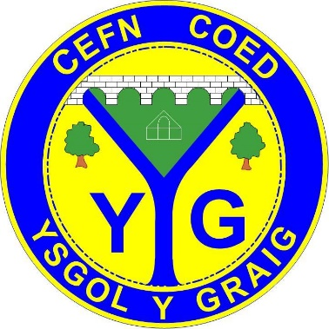
Yours sincerely,

M Harries
Headteacher

Contacting us:
School Address Local Authority Name of Chair
Headteacher MTCBC LA Mrs Ann James
Mr M. Harries C/O Sue Walker
Brewery Lane, Chief Education officer
Cefn Coed Unit 5, Triangle Business Park
Merthyr Tydfil Pentrebach
CF48 2LR CF48 4TQ

Email: office@ysgol-y-graig.merthyr.sch.uk

Here at Ysgol Y Graig we acknowledge the importance of having all the information you need in the easiest of conveniences. Therefore we have invested in a school website where you can access the information you require when you need it. The website and school twitter page is updated frequently with news, events and much more to ensure you are kept up-to-date with what’s happening in school.
Website: https://www.ysgolygraig.com/
Twitter: https://twitter.com/YYGPrimary

One vital feature of our class dojo and Text2parents service is the opportunity to communicate to parents through a notification service. Here you will receive notifications to your phone or tablets instantly. All you have to do is:
Download the apps on your mobiles and tablets.

Our Vision
Our vision is:

‘Opening eyes, developing minds, changing lives’

Our vision at Ysgol Y Graig can be expanded to read:
To open the eyes of our pupils to the opportunities of the world through direct and indirect experiences, to develop their minds through quality teaching, while giving pupils the desire to seek to better themselves with confidence and self assurance.’

These aims are supported by the premise of:

‘Achievement through Enjoyment’

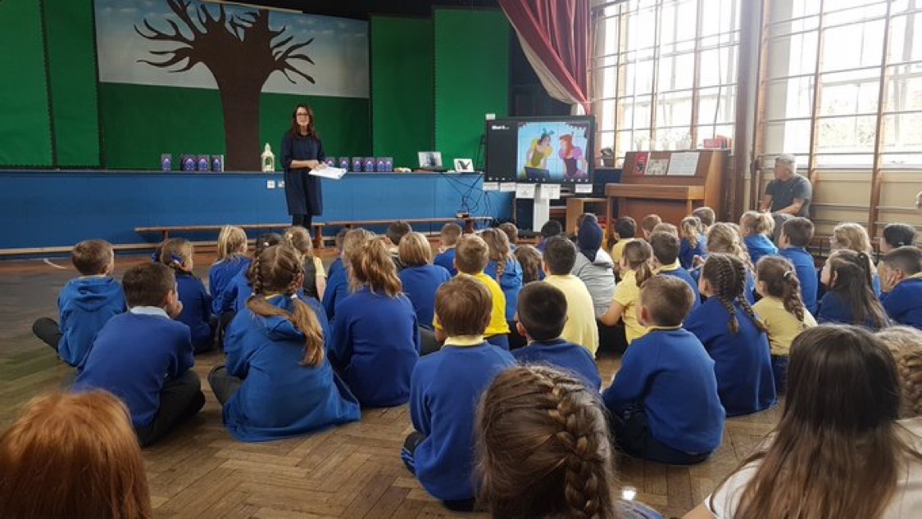
‘

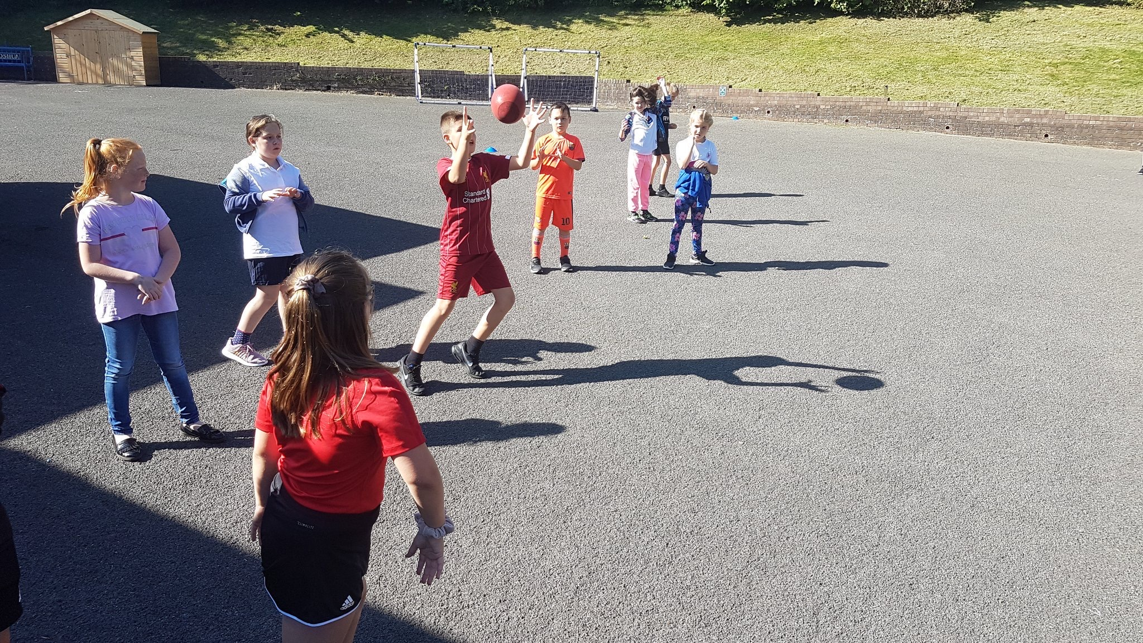

Key Information
  - Session Times: Foundation Phase Key Stage 2 (Years 3-6)
9:00- 9:05 (Registration) 9:00 – 9:05 (Registration)
9:05-10:30 (Lessons) 9:10 - 10:30 (Lessons)
10:30 – 10:45 (Assembly) 10:30 – 10:45 (Assembly)
10:45 - 11:05 (Break) 10:45 - 11:00 (Break)
11:05 – 12:00 (Lessons) 11:05 – 12:30 (Lessons)
12:00 – 1:00 (Lunch) 12:30 - 1:15 (Lunch)
1:00 – 1:05 (Registration) 1:15 – 1:20 (Registration)
1:05 – 3:10 (Nursery Lessons) 1:20 – 3:20 (Lessons) 3:10 (Nursery Home time)
1:05 – 3:15 (FP Lessons)
3:15 (FP Home time) 3:20 (KS 2 Home-time)
Breakfast Club:
The school provides the opportunity of a breakfast club from 8:00am to 8:40am. This service is free of charge. A form is available from the school office if you wish your child to attend. Children are supervised until 8:50am.
  - Afterschool Clubs:
  - Ysgol Y Graig have established a variety of after school clubs that may interest your child. At the start of each year a list of available clubs will be distributed to parents with a choice of options for the year.

YSGOL Y GRAIG AFTER SCHOOL CLUB: @PLAY
We host a well established after school club. Children attend from the end of the school day until 5:15. The Play Leader and Assistant who run the club are also Learning Assistants from within the school and this is a great advantage because they already know the children.
  - Attendance:
  - All parents/guardians are required to notify the school of any absence via writing or telephone. Failure to do so will result in your child’s absence being entered into the school register as an ‘Unauthorised absence’. The school register opens at 9:00 and closes at 9:05 am. Any arrivals after 9 am have to enter the building through the main door and will be marked as ‘Late’. Parents are encouraged, where possible, to make any medical appointments outside of school hours, as not to affect their child’s education. Parents can check attendance via the school website.
Please note the Local Authority guidance below.
Following the court ruling in response to the issuing of a Fixed Penalty Notice (FPN) for a holiday taken during term time, there have been many queries regarding term time absences.

In order to clarify the position for parents/carers, the position remains as follows;

A FPN may be considered at the Head teacher’s discretion under the following circumstances;
- Where at least 10 sessions (5 school days) are lost due to any unauthorised absence during the current term. The days do not need to be consecutive.
- Where there are at least 10 sessions of persistent late arrival at school during the current term.
Failure to pay the FPN will result in the case being referred to the Legal Department. The case will then be considered for prosecution in the Magistrates Court under the Education Act 1996.

IT IS THE POLICY OF YSGOL Y GRAIG THAT ALL HOLIDAYS ARE MARKED AS UNAUTHORISED ABSENCE. THE EXCEPTIONS TO THIS RULE ARE FOR THE CHILDREN WITH PARENTS IN THE ARMED FORCES AND ESSENTIAL PUBLIC SERVICES ONLY.
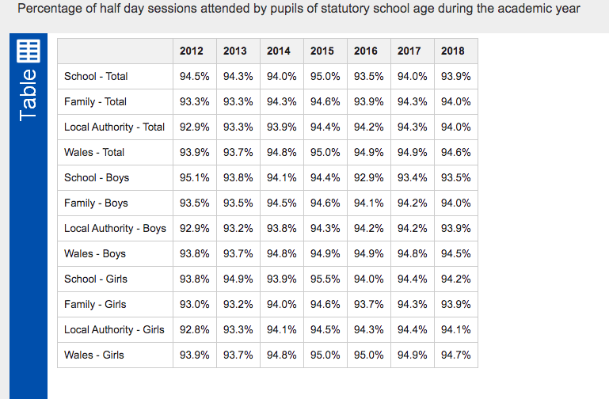

  - Attendance Figures

  - Admissions:
Applications for your child to start/attend Ysgol Y Graig need to be completed through the MTCBC website:
  - https://www.merthyr.gov.uk/resident/schools-and-learning/school-admissions/apply-for-a-school-place/
  - School Uniform:
Polo Shirt- Yellow
School Sweatshirt/ Hoodies/ Cardigans- Royal Blue
Joggers/ Trousers/Shorts/Skirts- Grey
Shoes- Black
Summer Dress- Blue/Yellow
(We ask that all items of clothing are labelled with the child’s name)
  - Dress/Accessory Safety:
When pupils are participating in physical activities pupils are asked to remove any accessories that may cause harm/injury to themselves or others during the activity, items such as watches or earrings.
We ask that children do not attend school with any jewellery or accessories of significant value as the school is not liable for loss or damage to these items.
  - PE Kit:
Pupils will be taking part in P.E. on a weekly basis that consists of taking part in sessions outside on the yard or in the school hall. The required sportswear for pupils are:
- Sports t-shirt
- Shorts or sports joggers
- Appropriate sports footwear.
  - Emergency Contact Information:
It is essential that parents/guardians provide the school with a record of their contact details. A starter pack will be issued to each child upon joining the school. We stress the importance of informing the school of any changes to address/phone-mobile numbers/medical needs to ensure our records are up-to-date in the case of an emergency.
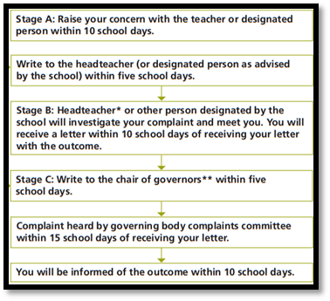
  - Complaints:
The diagram to the right is the complaints procedure any parents/guardians need to follow should an issue arise.
It is expected that the majority of issues are dealt with within stage A, however, if this is not the case proceed to the next step.
For any further information about this issue please see our ‘Complaints Policy’ on our school website.

  - Road safety and parking near school:
- Drive SLOWLY at all times
- Ensure that your children WALK ON THE PAVEMENT
- Please avoid BLOCKING resident’s driveways
Milk Provision
The Local Education Authority provides free milk to all pupils under 7 years old under their free milk scheme.
URDD
We take great pleasure in ensuring that pupils are given the opportunity to be a part of this prestigious establishment. An annual membership fee is collected.
Charges:
No fees are charged for school activities with the exception of the following:
- Educational visits, voluntary contributions are sought from parents
- Ex-curricular activities that are organized by external providers may require a voluntary contribution.

School Meals:
School dinners are provided to every child wishing to have them for a price of £2.30 per day, or £11.50 per week which is set by MTCBC Council. We kindly ask that that dinner money is paid on a Monday, and presented in a sealed envelope labelled with your child’s name. All cheques made payable to MTCBC. A cashless system will be piloted this Autumn.
Meals are prepared in the kitchen which is situated inside the school building. If parents would like to apply for free school meals, they need to complete an application form online at MTCBC
First Aid/ Injuries:
Members of staff in each phase are trained to administer minor first aid. Pupils will receive an accident slip to inform parents of the incident. Serious injuries will require staff to contact parents for safety precautions.
Emergency School Closure/ Evacuation Procedures:
In an event of a school closure/ evacuation the evacuation safe zones are:
- Key Stage 2 Yard
- Community centre in event of full site evacuation
- Lock down drills are also shared parents
Medicines
Parents need to complete a medical request form available from the school office for staff to administer medicines. This will only be granted in special cases – if the child is ill enough to require frequent medication then the child will be deemed too ill to be attending school. Of course, with permanent/ major medical conditions (for example, diabetes or cystic fibrosis) staff will be permitted to administer appropriate medication following guidance/ training from the child’s parents/ guardians. With pupils who suffer from asthma and need to keep inhalers in school, parents should discuss with the class teacher a suitable place for the inhaler to be kept and whether the child requires assistance in using the inhaler.
The school advises all parents to speak with their child’s new class teacher at the start of each school year regarding any medical issues.

Personal Belongings (e.g. Mobile Phones)
Children are strongly discouraged from bringing items such as mobile phones, iPods, digital cameras, MP3 players, Gameboys and any similar items to school. The school will accept no responsibility for the loss or damage of personal belongings brought to school. If children are required to bring a mobile phone on any occasion then it should be handed to a member of staff at the school reception for safekeeping until the end of the day.

Our Staff
Headteacher: Mr M. Harries
Senior Leadership Staff: Mrs Lisa Jones, Mrs Janet Thomas
Staff Name | Responsibility | Year Group
Matthew Harries | Headteacher, Strategic vision, School Performance, Data, Finance, Safeguarding, Premises
Lisa Jones | Deputy Head teacher, FP Leader Outdoor learning, Leader of T & L, Attendance, Family Liaison Officer, School Council | Year 2
Janet Thomas | KS2 leader, Safeguarding & Mathematics, NQT student Mentor, EVC coordinator, MAT | Year 6
Helen Pomeroy | Nurture teacher, ALNCo | Nurture
Samuel Aylward | Year 5 teacher, ICT, assistant PE, DT | Year 5
Matthew Howells | Year 4 teacher, Science & Technology, ECO schools & Forest schools, Assistant Welsh | Year 4
Siobhan Lynch | Year 3 teacher (job share) RE, PSE | Year 3
Joanne Thomas | Year 3 teacher (job Share) English, Literacy and PE | Year 3
Clare Jones | Year 1 teacher, RWI, Humanities, Assistant FP Lead | Year 1
Rebecca Hill | Reception teacher, Welsh, Healthy schools, Eco Schools, EY assistant Lead | Reception
Amy Sofianos | Nursery teacher, Music, Art, Expressive Arts | Nursery
Jack Andrews | HLTA Nurture class | Nurture
Zena Harris | HLTA FP, Playground leader, Prefect and Library lead | Year 2
Karen Morgan | HLTA PPA, assistant PSE/RE/Music | PPA
Natasha Jones | LSA Nurture | Nurture
Edward Monger | LSA KS 2 interventions | KS 2
Elanna Davies | LSA 1;1 and group interventions | FP
Dee Thomas | LSA FP | Year 1
Delyth Goodall | LSA & ELSA | Year 1
Nicola Rees | LSA FP | Reception
Laura Toon | LSA 1:1 and group FP | Reception
Sarah Lewis | LSA FP Outdoor learning | Nursery
Paige Stone | LSA FP | Nursery
Terri Palmer | School Administrator
David Phillips | Caretaker
June Harper | Cook in Charge

Ysgol Y Graig Governing Body
The school has a Governing Body which is appointed by the LEA. The Governing Body meets regularly to discuss and plan the work of the school, the maintenance of the buildings and site, the financial management of the school and staffing issues. An annual report is compiled on an annual basis and is placed on the school website; parents are also welcome to request a meeting with the governors once a year.

Name: | Position
Ann James | Chairperson
Mr M Harries Headteacher | Headteacher
Anthony Owen | Vice-Chairperson
Andrew Williams | Parent Governor
Leighton Davies | Community Governor
Tanya Davies | Community Governor
Roberta Halliday | Community Governor
Cllr Howard Barrett | LA Governor
Cllr Lisa Mytton | LA Governor
Cllr Clive Tovey | LA Governor
Emma Bush | Parent Governor
Mrs Z Harris | Staff Governor
Miss A Sofianos | Teacher Governor
Mrs J Thomas | Teacher Governor
Mr K Maher | LA Governor
Catherine Bush | Parent
Naomi Brown | Parent

Safeguarding
Safeguarding Officers: Mrs J. Thomas
Mrs. R Hill
Mr. M Harries
All staff in Ysgol Y Graig recognises our moral and statutory responsibility to safeguard and protect the pupils in our school. We will endeavour to provide a safe and welcoming environment for all children where they are all respected and valued equally. Up to date and relevant training ensures that we will be alert to the signs of abuse and neglect, and will follow our procedures to ensure that our children receive protection when necessary.

If you are concerned about the safety or welfare of your child, or a child you know, you should act without delay.

Our designated person for child protection is – Mrs J Thomas (Senior Teacher)
Our designated Governor for child protection is – Dr Clive Tovey

We help to keep our pupils safe by:
• Having an up to date safeguarding policy
• Having other safe guarding policies, such as Anti-Bullying and Internet Safety
• Checking the suitability of all our staff to work with children
• Encouraging pupils to tell us if something is wrong
• Adhering to health and safety regulations
• Training all our staff to recognise and respond to child welfare concerns
• Appointing a designated person for child protection
• Working in partnership with parents, carers and outside agencies

The Governing Body has adopted a complaints Procedure which is reviewed annually. A copy of the complaints Procedure is available at the school office or on our school website.
Any parents/carers who feel they would like to lodge a complaint are encouraged to follow our procedure.

The school and the curriculum
The Foundation Phase
Children in Nursery, Reception, Year 1 and Year 2 will follow the Foundation Phase curriculum.
The foundation phase curriculum in Ysgol Y Graig is balanced, relevant and differentiated to meet the needs of all our learners. The children will develop their skills and abilities through seven areas of learning:
- Personal and Social Development, Well-Being and Cultural Diversity
- Language, Literacy and Communication skills
- Mathematical Development
- Bilingualism
- Knowledge and Understanding of the World
- Physical Development
- Creative Development
These areas and activities will provide your children with a solid foundation for their education. They will be supported with several members of staff and their development will be closely monitored and recorded.
Key Stage 2
Pupils in years 3, 4, 5 and 6 are taught subjects in line with the National Curriculum for Wales. The subjects taught in Key Stage 2 are:
- Mathematics – Numeracy
- English- Literacy
- Science
- Welsh
- Information Computer Technology (ICT)
- Design Technology
- History
- Geography
- Art
- Music
- Physical Education
- Personal and Social Education
- Religious Education
Lessons are taught using a range of teaching strategies, in whole and small group activities. In 2008 the National Curriculum changed. The focus on lessons is no longer about the content and rather the skills they are developing and where they can be applied to other real-life scenarios.
Inclusion and Equality
Ysgol Y Graig has an Equal Opportunities policy which aims to provide every child with the opportunity to achieve their fullest potential. Ysgol Y Graig ensures that all pupils have the same learning opportunities regardless of factors such as background, ethnicity or gender.
In order to ensure that our pupils are fully prepared for the real-world, we strongly encourage that the pupils respect others and in sensitive areas in assemblies and Personal and Social development they understand the importance of fairness, tolerance and freedom of people’s ideas and opinions.
Health and Well-being
The school nurse regularly visits the school. Hearing and visual examinations and measurements of height and weight are conducted during your child’s time in school. Please notify the school if your child has any medical conditions, allergies or in need of any additional care and support.
Behaviour & School Rules
Ysgol Y Graig places great emphasis on all our pupils behaving positively and following school and class rules. Good behaviour is essential to maintain our happy school ethos and to ensure all pupils make maximum progress with their learning.
All pupils are required to:
1) Treat other children fairly and kindly
2) Treat and speak to all staff with respect
3) Respect other people’s property
4) Ensure appropriate language is used in classrooms and the playground
5) Avoid calling other children names or saying upsetting things about them
6) Ensure no pushing, hitting, kicking, etc. takes place
7) Always work to the best of their ability without distraction or disruption
This ethos is summarised by a memorable rule:
Treat others as you would like to be treated.

The Headteacher and/or class teachers will arrange meetings with parents/
guardians to discuss any negative behaviour patterns experienced with individual
children.
Additional Learning Needs (ALN)
The school’s Additional Learning Needs provision complies with the guidelines of the Code of Practice for Identifying and Assessing Special Educational Needs that was introduced following the 1993 Education Act. Children with Additional Learning Needs are taught in mainstream classes along with their peer group and where appropriate, are supported through relevant differentiated work and interventions where necessary. We have strong connections with outside agencies and Educational/behavioural Psychologists to support children and their needs.
A pupil identified with ALN will be given an Individual Education Plan (IEP) which sets out several ‘small steps’ to achieve targets. The teacher will work with the child Additional Learning Needs Co-ordinator to set targets which are reviewed at the end of the term.
The school currently an LA pilot nurture setting to support pupils with emotional and behavioural difficulties.
English as an Additional Language (EAL)
Ysgol Y Graig has a number of EAL pupils attending our school. Our staff are trained to ensure that children with English as an Additional Language are fully supported to give them the best opportunity to develop the English language.
Extra support is available for pupils through outdoor agencies who attend school on a regular basis to monitor progress.
Educational Visits
Visits are arranged to help support and enhance children’s current learning of a topic or theme, trips may include visiting places of historical interest, local places to see the industry and the daily working activity in Merthyr and around Wales.
Pupils in Year 5/6 have the opportunity to attend a residential trip in a to engage in outdoor recreational activities.
These activities and visits are considered to be opportunities for children to exchange experiences, learn to develop independence and nurture citizenship in an environment that is based on the Welsh way of life.
Health/ Sex Education
Sex Education is introduced as part of the Health Education programme and is done sensitively as part of a theme. It is not taught as an individual subject.
During the summer term, the school’s Health Visitor delivers “Sex Education” lessons to year 6 boys and girls and year 5 girls, which discuss the following:-
Relationships; Changes to the Body;
Further Changes to the Body;
The Community Health Visitor provides assistance when necessary.

Collective Worship
All registered pupils take part in a collective act of worship every day. Collective worship is “wholly or mainly of a Christian character” i.e. it reflects “a broad tradition of Christian belief”. The school has regular visits from the local victor and pastor around times of Christian significance.

Any parent has the right withdraw their child from collective worship on religious grounds and arrangements will be made for their supervision by an adult during those periods. The teachers’ rights are also protected.
Sport
Ysgol Y Graig places a great emphasis on being healthy and active and positively encourage children to take part in as much physical and sporting activities as possible. Every year group participates in physical education lessons every week that range from ball sports, gymnastics, dance and athletics.
All Key Stage 2 class have the opportunity to part-take in a 2 week block of swimming lessons conducted by swimming instructors at Merthyr Leisure Centre.
After school sports clubs are held weekly for pupils who wish to engage with extra-curricular sporting activities.
Boys and girls in year 4-6 have the opportunity to represent the school in sporting events throughout the year.
Transition to Secondary School
When pupils reach the end of Year 5 they will begin the process of engaging with activities conducted by secondary schools. As we are located in the catchment area for Pen Y Dre High School, they provide the dominant opportunities for our pupils. Cyfarthfa High School also receives our pupils.
These secondary schools conduct activities aimed at preparing pupils for their transition to secondary school. They do this through a range of activities such as sporting and music events as well as lessons taught by subject teachers. The pupils will have numerous opportunities to visit Pen Y Dre High School in year 6 to establish relationships with staff and pupils that will meet.
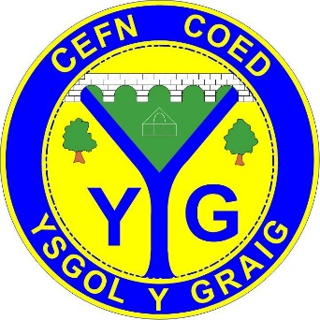

Pupil Voice
In Ysgol Y Graig we recognise the importance and impact of listening to and valuing the ideas and opinions of our students. Therefore we ensure that the pupils have the opportunity to suggest, challenge and comment on ideas and decisions happening in school.
This is how we do it:
School Council
We have an active school council with members elected from each class. School Councillors are involved in the running of the school, making decisions, fund-raising for the school and charities and create a positive attitude through setting a good example and informing pupils of expectations.
Eco Council
A group of pupils are elected from each class who are responsible for ensuring the school complies with eco-schools code of conduct. Pupils aim is to sustain the green eco flag Award.
Criw Cymraeg
Promoting Welsh amongst our pupils is important in Ysgol Y Graig, therefore a group of representatives throughout the school are nominated to represent their class and school in Criw Cymraeg. Pupils aim to promote Welsh within our school. Regular meetings will be conduct to plan and conduct activities throughout the year to achieve this goal.
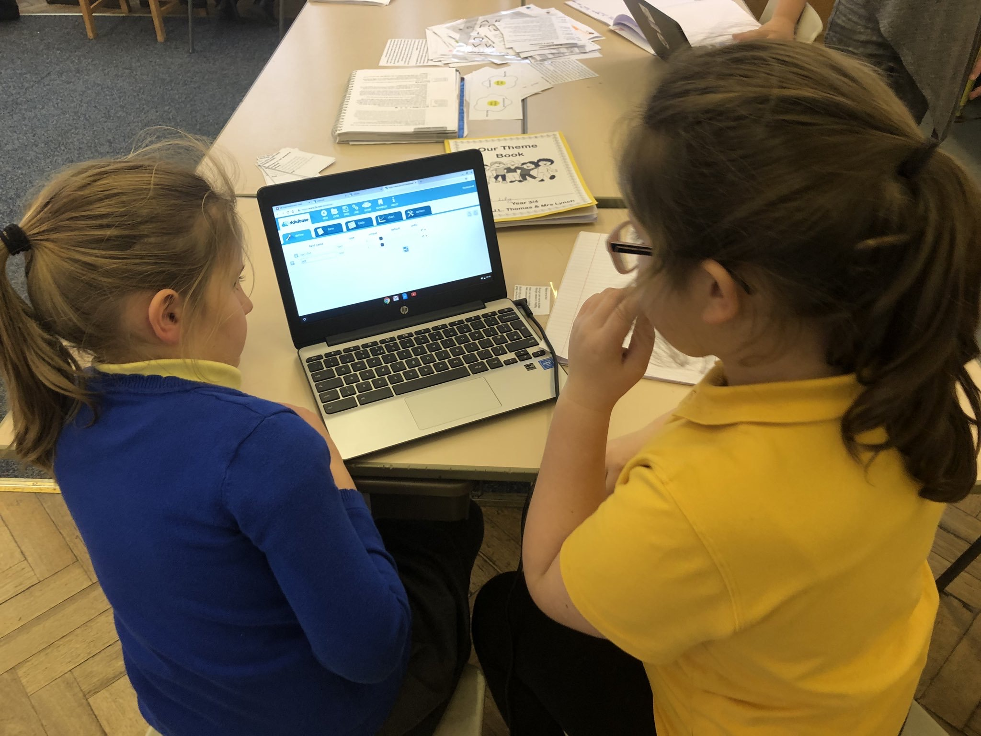
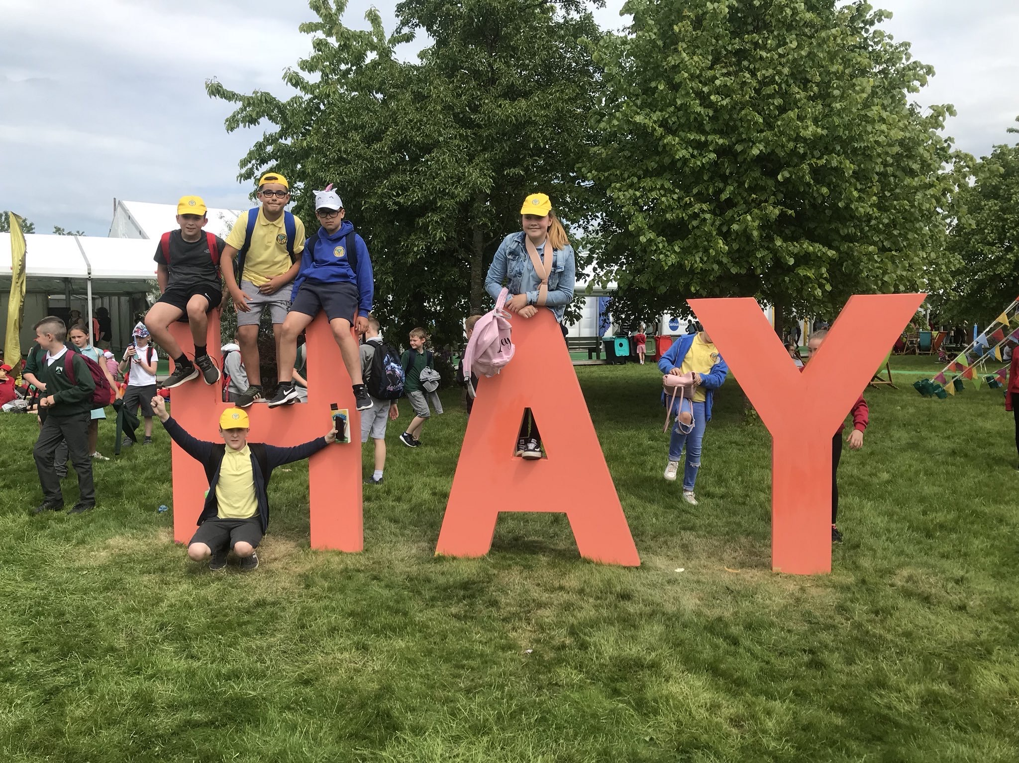

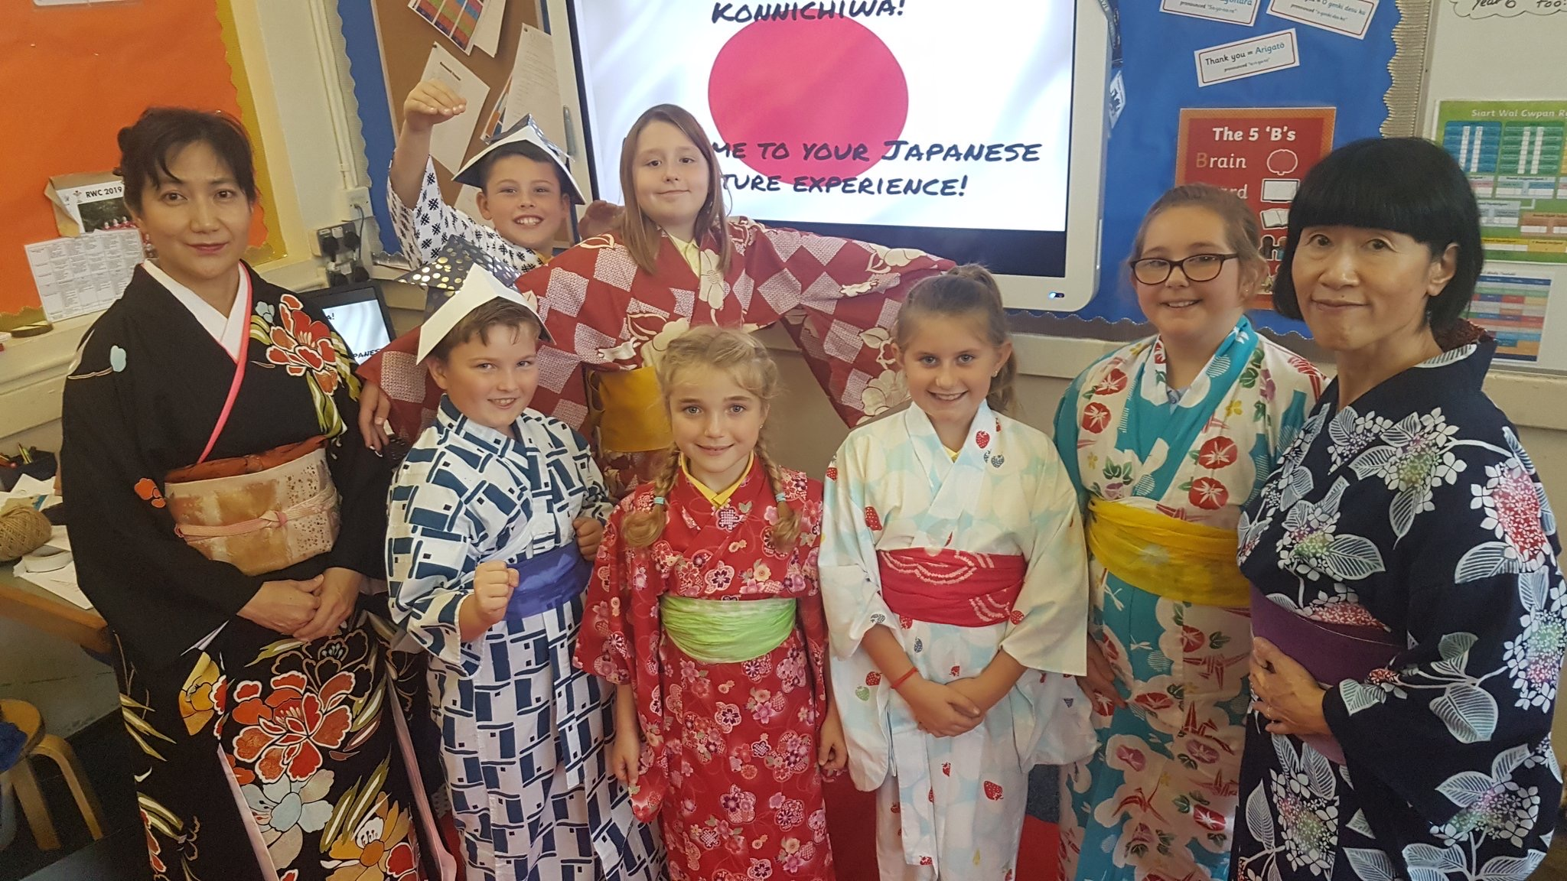

Home-School Links
In Ysgol Y Graig we value the importance of close links between our pupils and their families. These links are made through the following:
- Home/School agreement
- Homework activities
Homework provides the opportunity for children to build on the skills and knowledge they have learnt in school. It also helps children to develop their individual learning skills. We focus of giving homework that will develop their literacy and numeracy skills, however, there will be extra tasks linked to the theme they are learning.
We do not give pupils homework that they have not covered in school. Teachers set homework to ensure that the children fully understand the topic/skill they have been developing.
We encourage parental engagement with homework in the following ways:
- Giving pupils the opportunity to work where they can concentrate
- By showing an interest in what they are doing
- By encouraging that their work is neatly presented in their books/worksheets
- By ensuring that their homework is in by the required deadline.
Please encourage your child to look after any resources they bring home, books are expensive and should be maintained to a neat and clean standard.
If you have any questions regarding homework, don’t hesitate to speak to the class teacher.
- Meetings with Parents
We aim to hold a parent’s evening twice a year to give parents/guardians the opportunities to meet with the child’s teacher to discuss their development and progress.
The school will issue each child with a report to summarise your child’s progress at the end of each academic year. Parents will be given the opportunity of an additional parents evening if you wish to discuss the report with the class teacher.
(If you wish for an additional copy of the school report then ensure you contact the school).
Children who receive additional support or are part of ‘School Action Plus’ will receive extra reviews; these meetings will discuss in detail your child’s progress through their IEP.

- Friends of Ysgol Y Graig
Our Parent’s Association committee arrange fund-raising and social events throughout the year. The money raised has and will provide the school and pupils with vital resources needed in their learning.
Your support for these events would be greatly appreciated and if you would like to help or be involved in this committee, please let us know!

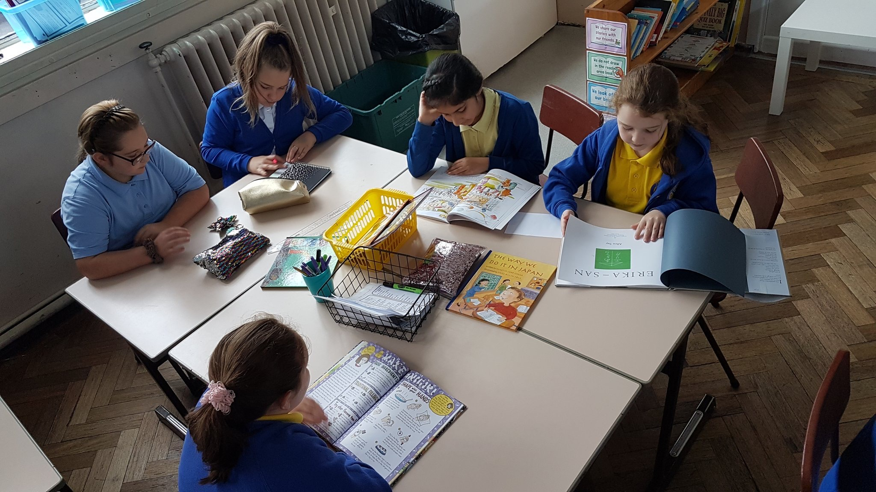

Yearly Term ‘Themes’ Timetable
 | Autumn |  | Spring |  | Summer
Nursery | Guess How Much I love you? | Christmas in my Home | Curious and Creative | Down on the farm | Fun and Games
Reception | My Friends and my feelings | My big Christmas Sack (Toys) | Super Structures | What’s in your back garden? | Telling Tales
Year 1 | Community Explorer | Electric Rainbow | Making and Creating | Living Things | Wish you were here
Year 2 | Community Explorer | Electric Rainbow | Making and Creating | Living Things | Wish you were here

 | Autumn |  | Spring |  | Summer
Year 3 | Wildwood | Disaster Zone | Dream for a Druid | Flight engineers | Flight engineers/ Sportswear designers | Sportswear designers
Year 4 | Travel Agents | Sensoria | Children of the revolution | Global Gourmet | Bones, Blood and Gory bits
Year 5 | Japan | Blitz | Skin Deep | Allotment | More than Mods & Rockers/ Allotment
Year 6 | Midsummer nights dream | Blitz | Skin Deep | Allotment | More than Mods & Rockers/ Allotment

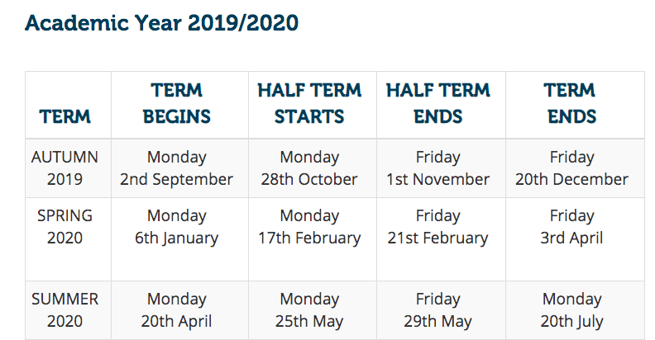
School Term Holidays and Dates

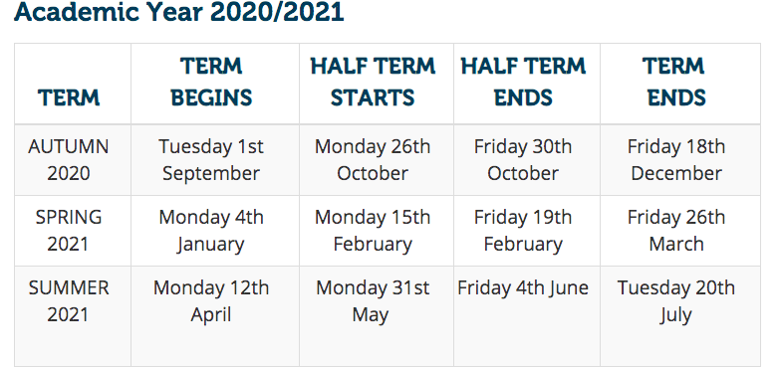

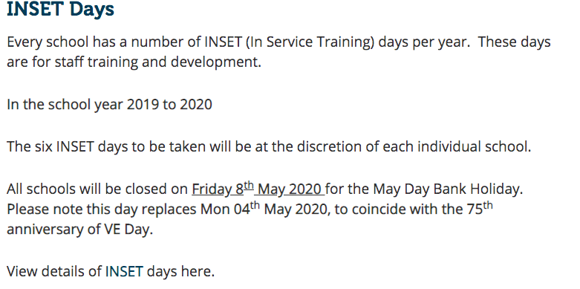

Pupil Attainment FP 2018-19
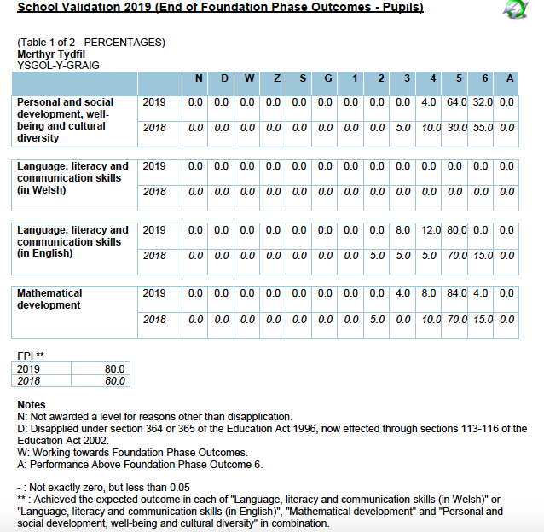

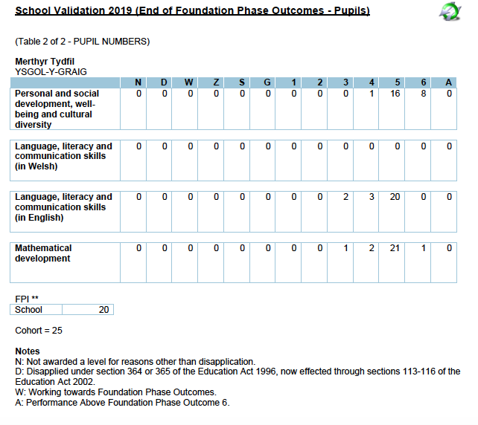

Pupil Attainment KS2 2018-19

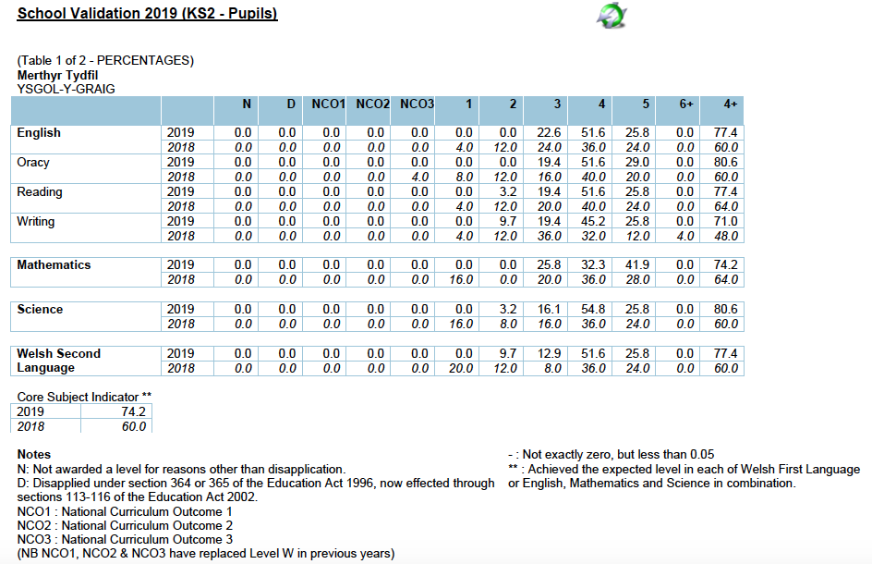

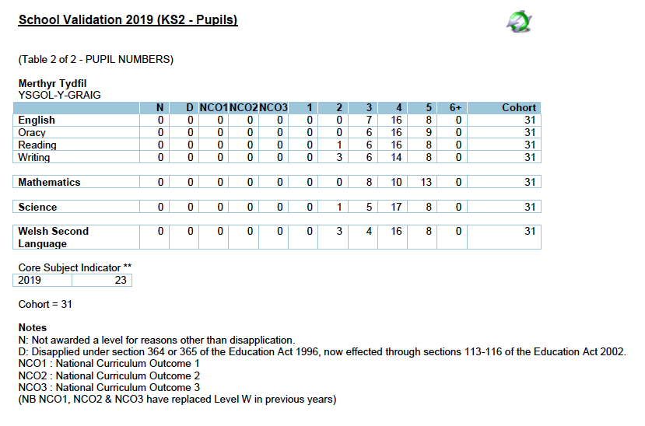

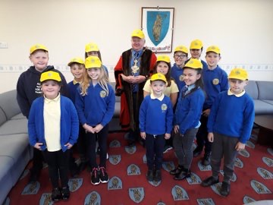

YSGOL Y Graig Primary School
PROSPECTUS-HANDBOOK
2019-2020

